https://www.helpnetsecurity.com/2020/09/28/cybersecurity-lessons-learned-data-breaches-brand-trust-matters/

Bindu Sundaresan, Director, AT&T Cybersecurity
September 28, 2020

Cybersecurity lessons learned from data breaches and brand trust matters
Your brand is a valuable asset, but it’s also a great attack vector. Threat actors exploit the public’s trust of your brand when they phish under your name or when they counterfeit your products. The problem gets harder because you engage with the world across so many digital platforms – the web, social media, mobile apps. These engagements are obviously crucial to your business.
Something else should be obvious as well: guarding your digital trust – public confidence in your digital security – is make-or-break for your business, not just part of your compliance checklist.
COVID-19 has put a renewed spotlight on the importance of defending against cyberattacks and data breaches as more users are accessing data from remote or non-traditional locations. Crisis fuels cybercrime and we have seen that hacking has increased substantially as digital transformation initiatives have accelerated and many employees have been working from home without adequate firewalls and back-up protection.
The impact of cybersecurity breaches is no longer constrained to the IT department. The frequency and sophistication of ransomware, phishing schemes, and data breaches have the potential to destroy both brand health and financial viability. Organizations across industry verticals have seen their systems breached as cyber thieves have tried to take advantage of a crisis.
Good governance will be essential for handling the management of cyber issues. Strong cybersecurity will also be important to show customers that steps are being taken to avoid hackers and keep their data safe.
The COVID crisis has not changed the cybersecurity fundamentals. What will the new normal be like? While the COVID pandemic has turned business and society upside down, well-established cybersecurity practices – some known for decades – remain the best way to protect yourself.

1. Data must be governed
Data governance is the capability within an organization to help provide for and protect for high quality data throughout the lifecycle of that data. This includes data integrity, data security, availability, and consistency. Data governance includes people, processes, and technology that help enable appropriate handling of the data across the organization. Data governance program policies include:
- Delineating accountability for those responsible for data and data assets
- Assigning responsibility to appropriate levels in the organization for managing and protecting the data
- Determining who can take what actions, with what data, under what circumstances, using what methods
- Identifying safeguards to protect data
- Providing integrity controls to provide for the quality and accuracy of data

2. Patch management and vulnerability management: Two sides of a coin
Address threats with vulnerability management. Bad actors look to take advantage of discovered vulnerabilities in an attempt to infect a workstation or server. Managing threats is a reactive process where the threat must be actively present, whereas vulnerability management is proactive, seeking to close the security gaps that exist before they are taken advantage of.
It’s more than just patching vulnerabilities. Formal vulnerability management doesn’t simply involve the act of patching and reconfiguring insecure settings. Vulnerability management is a disciplined practice that requires an organizational mindset within IT that new vulnerabilities are found daily requiring the need for continual discovery and remediation.

3. Not “if” but “when”: Assume you’re already hacked
If you build your operations and defense with this premise in mind, your chances of helping to detect these types of attacks and preventing the breaches are much greater than most organizations today.

The importance of incident response steps
A data breach should be viewed as a “when” not “if” occurrence, so be prepared for it. Under the pressure of a critical-level incident is no time to be figuring out your game plan. Your future self will thank you for the time and effort you invest on the front end.
Incident response can be stressful and is stressful when a critical asset is involved and you realize there’s an actual threat. Incident response steps help in these stressing, high pressure situations to more quickly guide you to successful containment and recovery. Response time is critical to minimizing damages. With every second counting, having a plan to follow already in place is the key to success.

4. Your size does not mean security maturity
It does not matter how big you are or the resources your team can access. As defenders, we always think, “If I only had enough money or people, I could solve this problem.” We need to change our thinking. It’s not how much you spend but rather, is that spend an effective use? Does it allow your team to disrupt attacks or just wait to be alerted (maybe)? No matter where an organization is on its journey toward security maturity, a risk assessment can prove invaluable in deciding where and when it needs most improvement.
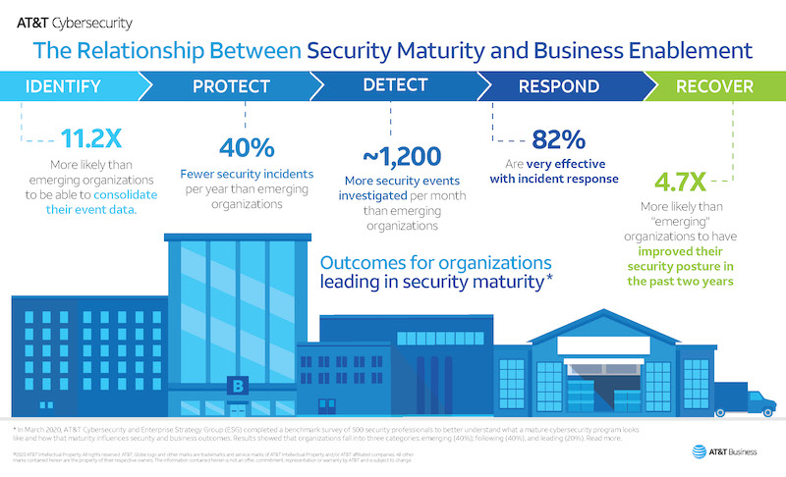
For more mature organizations, the risk assessment process will focus less on discovering major controls gaps and more on finding subtler opportunities for continuously improving the program. An assessment of a less mature program is likely to find misalignments with business goals, inefficiencies in processes or architecture, and places where protections could be taken to another level of effectiveness.

5. Do more with less
Limited budgets, limited staff, limited time. Any security professional will have dealt with all of these repeatedly while trying to launch new initiatives or when completing day-to-day tasks. They are possibly the most severe and dangerous adversaries that many cybersecurity professionals will face. They affect every organization regardless of industry, size, or location and pose an existential threat to even the most prepared company. There is no easy way to contain them either, since no company has unlimited funding or time, and the lack of cybersecurity professionals makes filling roles incredibly tricky.
How can organizations cope with these natural limitations? The answer is resource prioritization, along with a healthy dose of operational improvements. By identifying areas where processes can be streamlined and understanding what the most significant risks are, organizations can begin to help protect their systems while staying within their constraints.

6. Rome wasn’t built in a day
An edict out of the IT department won’t get the job done. Building a security culture takes time and effort. What’s more, cybersecurity awareness training ought to be a regular occurrence — once a quarter at a minimum — where it’s an ongoing conversation with employees. One-and-done won’t suffice.
People have short memories, so repetition is altogether appropriate when it comes to a topic that’s so strategic to the organization. This also needs to be part of a broader top-down effort starting with senior management. Awareness training should be incorporated across all organizations, not just limited to governance, threat detection, and incident response plans. The campaign should involve more than serving up a dry set of rules, separate from the broader business reality.

