https://www.invincea.com/2016/07/still-sexy-password-stealing-malware/

Still Sexy: Password Stealing Malware
By PAT BELCHER
Jul 14, 2016
How much are your passwords worth? Your bank account password might be worth whatever is in your checking account. But is that more or less valuable than your social media passwords? How about compared to your free online email accounts? What about your entertainment streaming accounts like Hulu or Netflix? Of course work related passwords to enterprise resources like the intranet, timekeeping, payroll, proxies or VPNs could also fetch a hefty sale on the criminal underground.
There is a family of malware being delivered by Weaponized Office documents that do nothing except steal passwords stored on a local system. These password stealing campaigns rival the volume of infections from Ransomware campaigns like Locky, Cerber and CryptXXX tracked by Invincea. But if Ransomware is so easy and profitable why are attackers still stealing passwords? Perhaps they are worth more than we think.
Historically, we’ve determined the value of stolen passwords based on their sale price on underground criminal forums. However, this is only one metric to determine their value, and may not tell the whole story. Perhaps the value of a password can be determined based on the value to the person stealing the password, not the person buying it second hand. How to do we determine that? Let’s start with the opportunity cost of stealing a password compared to launching a Ransomware attack, whose value is much easier to quantify.
Consider that harvesting passwords is equal in volume to any given Ransomware campaign, which nets an attacker about $750 for every 4 successful infections. This places the value of your stored passwords at around $185 dollars. Otherwise, given the popularity and success of Ransomware, the password stealing attackers would just choose instead to engage in Ransomware.
Detection for a Ransomware attack is about as simple as it gets as Ransomware victims are notified by a splash screen that they have been infected. However, a password stealer will leave no detectable traces to a victim that all of their passwords have been uploaded to a command and control server. Anyone could be a victim of password theft and not even notice it.

Password Stealing Malware
To show some insight into how pervasive password stealers are, we will take a look at the following incident from last week when an Invincea customer encountered a weaponized document.
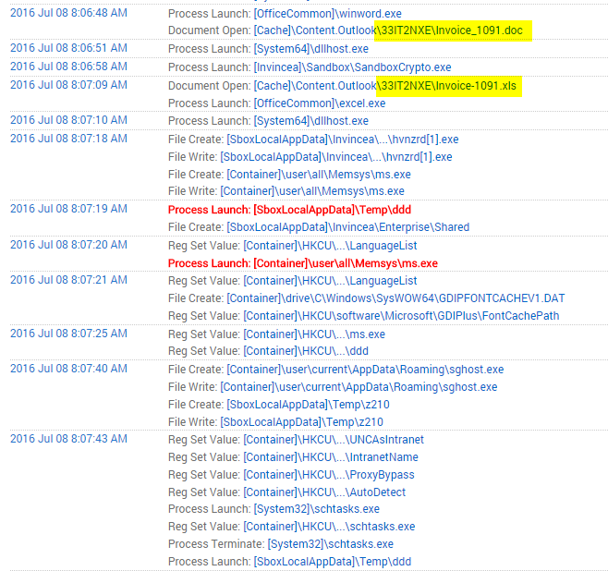
Figure 1: Weaponized doc drops filename ddd, which then creates ms.exe in the Memsys directory
In this example, the user opened a weaponized Office doc that posed as an invoice from within Outlook. This file wrote an extensionless file called ddd to the temp directory. That file in turn wrote ms.exe to all user’s Memsys directory. Antivirus vendors had a difficult time in identifying this malware natively. Below is a chart from ReversingLabs that graphs the ability of AV to identify this binary.
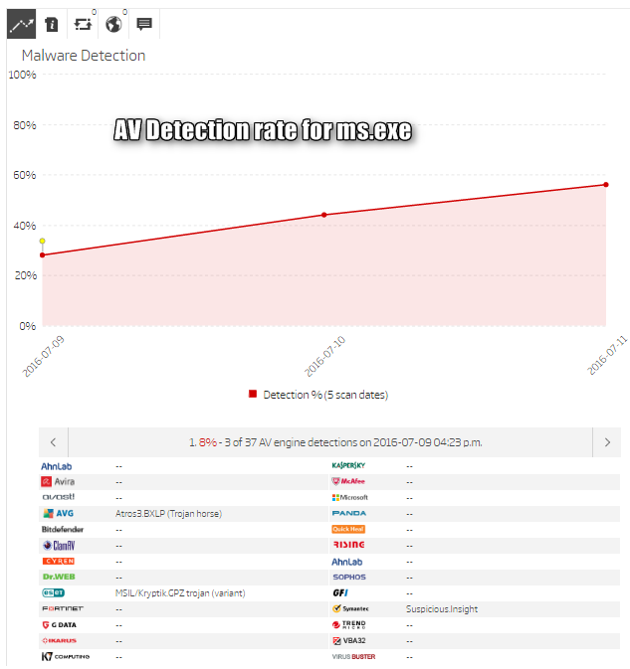
Figure 2: Invincea stopped this attack on July 8. Most AV companies could not identify this threat until July 10
Invincea has been tracking similar infections in the past where ms.exe is dropped into a Memsys directory. According to our DARPA funded Deep Learning detection engine, these binaries are related to the Pony password stealing family of malware. Each phishing run uses a different hash for the malware, making these new variants difficult to detect for legacy Antivirus engines. This is how they cluster in Invincea:
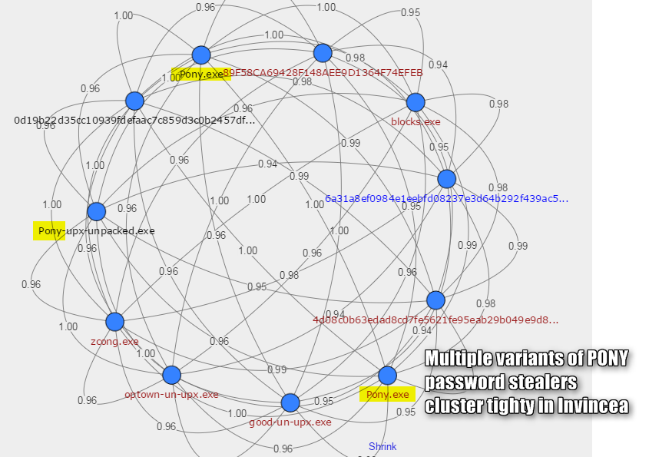
In addition, each binary shares similarities, accessing SMTP, SCP, SSH, HTT passwords and more.
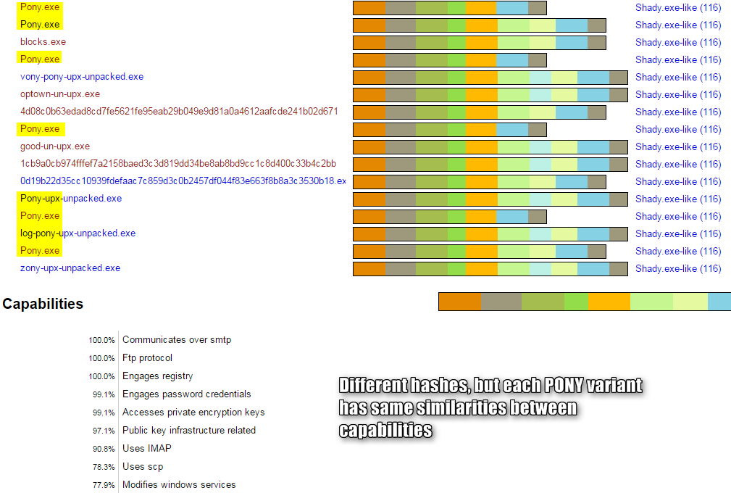

Invincea has seen over 116 similar samples of this family of the Pony malware. There are other families as well that cluster by different similarities. But this also represents 116 different Pony campaigns in which passwords were silently stolen from enterprise and home users who inadvertently opened a weaponized document thinking it was an invoice, subpoena or order confirmation. This represents potentially 116 different servers that could be storing the stolen passwords. You can browse this family of binaries here:
https://cynomix.invincea.com/sample/fba412258cebbe22e8a335d2bbd770556003ca2c
So what type of passwords are stolen? These binaries make that information pretty clear in its strings:
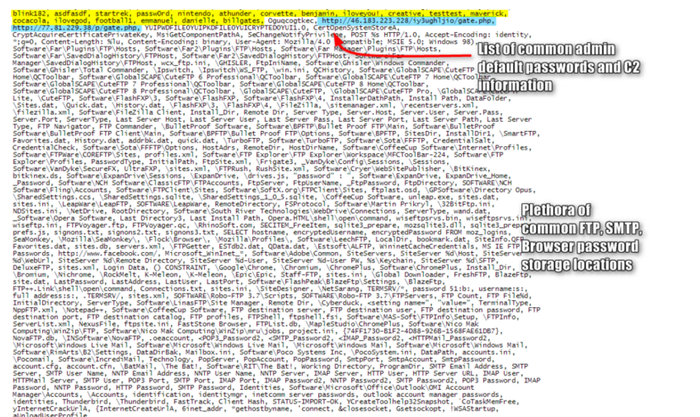
Basically, every password that is stored somewhere on the local system (registry, browser, local password databases and associated programs) that a hacker can think of is stolen from the system and uploaded to a couple of hard-coded command and control servers.

Hunting the Whales
Obviously stealing passwords to a few defunct accounts is not worth anything to the attacker, but the big payouts come when hundreds of passwords, including those of critical infrastructure are stolen.
Some of the most valuable passwords are of course for enterprise resources. Hackers will look for such passwords to assist in intrusions of corporate networks such as Web-based VPNs, internal resources, proxies and more. These can be grouped together and sold on dark forums on the Internet or used by the hacker themselves.
Root access to any open internet resource via FTP, SSH, HTTP console login, are the next highest in value, as they could supply attackers of other malware campaigns with free hosting for malware droppers or command and control.
SMTP resources are also valuable to provide attackers with accounts to use to send additional weaponized document spam and to also hijack other account information that requires email access to reset or change other passwords, such as social media accounts.

Which passwords should you change first?
We have all heard by now about the amount of Ransomware that is afflicting internet users. Yet password stealing malware is as large as any Ransomware campaign. Password stealing is at such a volume that it has become common for banks and other firms to uncover huge caches of passwords and notify victims of password theft.
Don’t wait for a third party to notify you that your passwords have fallen into the wrong hands. If you have to change all of your passwords, it helps to prioritize what should be changed first:
- Personal finance: Protect yourself and your finances first. Secure personal banking first, followed by any site that links to your online accounts, including retirement, investment and tax resources.
- Sources of income: If you suspect passwords to your work accounts have been compromised, protect your source of income by rescuing these assets next, including any cloud services and social media accounts used by the company.
- Email accounts: Since many services will alert or provide access to change passwords via email notification, secure access to your email services next.
- Telephony accounts: Smart phones could be compromised if attackers know passwords to online services such as iTunes.
- Subscription accounts: Services that are setup for autopay, including streaming entertainment, school lunch programs, lawn care, etc. should be secured next.
- Social media: Unless you are a high profile person or brand name, social media might be considered one of the least of your worries, so secure these next.
- Everything else: If you aren’t sure what else there is to secure, check your web browser’s stored passwords for saved URLs. You can find instructions on how to access saved passwords from your browser’s Help menu. Many people use “throwaway” accounts for anything such as online photo storage to pizza delivery and even these should be changed to prevent unwanted access.
To increase security, use two factor authentication on as many of your accounts as you can. Should your password be compromised for that service in the future, it will be worthless without access to the authenticator mechanism.

Conclusion
It wasn’t that long ago that CPU cycles and password guessing programs were used to crack passwords. Because of that threat, password complexity, password length, passphrases and password uniqueness became the mantra for security. But none of that matters if a weaponized document can easily snatch your super-complex and unique passwords to all of your online resources without your knowledge.
Password theft campaigns are equal in size to the best of Ransomware campaigns. The best way to keep your accounts secure is to make them worthless to an attacker. This means using two-factor authentication whenever and wherever possible. Change your other passwords that do not use two-factor often, at least once per quarter.
Finally, keep your endpoints secure from threats such as Ransomware and password theft by using X by Invincea. X by Invincea automatically prevents malware, even if it is malware that has never been seen before.

