https://www.darkreading.com/cloud/7-things-to-know-about-todays-ddos-attacks/d/d-id/1329758?image_number=1

8/30/2017
02:00 PM

Jai Vijayan
DDoS attacks are no longer something that just big companies in a few industries need to worry about. They have become a threat to every business.
1 of 8
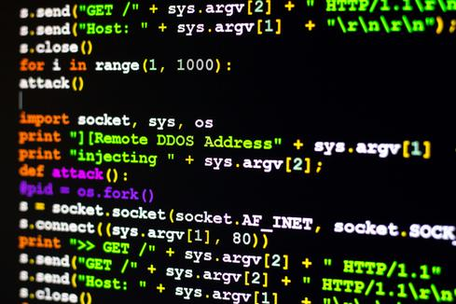
Image Source: DaLiu via Shutterstock


Don't Get Hung Up on Numbers
The actual number of DDoS attacks and their average size in terms of peak bandwidth and other measures tend to vary quite a bit on quarter-by-quarter, and sometimes even on a monthly, basis.
Take the Q2 2017 State of the Internet/Security Report from Akamai Technologies, which shows that DDoS attacks in the second quarter of this year increased by 28% compared to the previous quarter - after three straight quarters of decline. At the same time, Akamai didn't see any DDoS attack exceed 100Gbps in size during Q2.
In contrast, just last quarter Verisign reported at least one attack that topped 120Gbps, and an average peak-attack size that was 26% higher than the previous year.
Numbers alone shouldn't dictate mitigation strategies: it's more important to understand that DDoS attacks have become a threat to most organizations. Attackers have become more persistent than before and have more resources available to them. A DDoS attack does not have to be multiple gigabits-per-second in order to overwhelm your pipeline.
"The barrier to entry has been obliterated by new tools and attack services that enable anyone with an Internet connection and a grievance to launch an attack," says Kevin Whalen, a senior director of marketing at Arbor Networks. Any business can become a target for a real or perceived reason, he says.
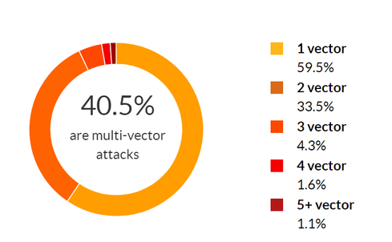

Multi-Vector Attacks are All the Rage

Multi-vector DDoS attacks that combine volumetric, application-level, and protocol-level elements have become a major threat. Attackers can launch these attacks using one vector at a time, or using all vectors concurrently in order to confuse targets.
Neustar reported a 322% increase in multi-vector DDoS attacks in 2016, compared to 2015 when UDP, TCP, and ICMP were the most popular attack vectors. As far back as the first quarter of 2016, companies such as Akamai were reporting more than 60% of their mitigation efforts as involving multi-vector DDoS attacks.
"These attacks are popular because they are difficult to defend against and are often highly effective," Whalen says.
In fact, the largest DDoS attack that Verisign observed in the first quarter of this year was a multi-vector attack with a peak bandwidth of 120Gbps and some 90 million packets per second. The attack, which consisted largely of TCP SYN and TCP RST traffic floods, persisted on a daily basis for two weeks and sent a sustained 60Gbps of traffic in one 15-hour stretch.
Whalen says 67% of the respondents in Arbor's latest Worldwide Infrastructure Security Report reported multi-vector DDoS attacks, up from 56% last year.
Image Source: Imperva Incapsula
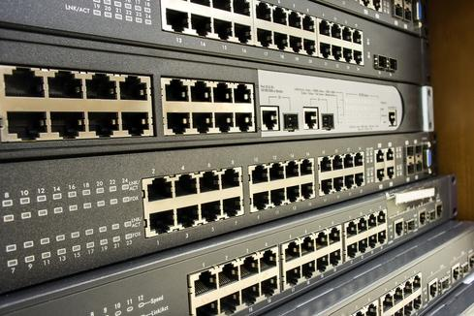

Network Layer/Volumetric Attacks Still the Most Common
Network-layer attacks or co-called volumetric DDoS attacks, continue to be the most common, says Avishay Zawoznik, research team leader at Imperva.
These attacks are characterized by high bandwidth or packets-per-second rates and target the bandwidth capacity of the victim's network pipes or the routing capacity of the victim's network devices. Common examples of volumetric attacks include SYN, ACK, UDP, and ICMP floods, Zawoznik says.
"In the last few months, the DDoS attacks we saw most were TCP attacks, NTP amplification attacks and multi-vector ones," he says. Obviously, the larger the attack either in terms of bandwidth, packets-per-second or requests per second, the higher the damage that volumetric attacks can cause he says.
Of the 4,051 DDoS attacks in total that Akamai helped its customers handle last quarter, some 99% were volumetric attacks. Of this, more than 80% were directed at companies in the gaming industry. Egypt had the highest number of unique IP addresses used in volumetric DDoS attacks accounting for 38% of the worldwide total.
Image Source: Chaiwat Srijankul via Shutterstock


Application-level DDoS Attacks are Growing
While network-layer DDoS attacks continue to be common, application-level attacks are rapidly rising.
Application-level DDoS attacks bombard business applications with a stream of seemingly legitimate requests until the applications are unable to respond. In contrast to volumetric attacks, application attacks have much lower traffic volume and are measured in requests per second (RPS). Typical attacks target HTTP and DNS services and increasingly, HTTPS as well.
Imperva's Global Threat landscape Report for Q1 2017 showed network-layer DDoS assaults decreasing for the fourth straight quarter, while application layer attacks reached an all time high of nearly 1,100 per week.
The largest of these attacks peaked at some 176,00 RPS, which was larger than the biggest application-layer attack that Imperva mitigated in all of 2016. "These attacks are aimed at consuming the computing resources of servers, Web servers, databases, etc.," says Zawoznik. Typical attacks involve floods of HTTP GET, POST, and PUSH requests directed at the target application, he says.
According to Arbor, DNS attacks accounted for 81% of all reported application-layer attacks last year and replaced HTTP as the most targeted service.
Image Source: Scanrail1 via Shutterstock


Majority of DDoS Attacks are Small and Brief
The reality is that the vast majority of DDoS attacks — even the volumetric ones — involve relatively low traffic volumes.
In fact, 80% of the DDoS attacks that Corero Network Security mitigated for its customers in the first quarter of 2017 were less than 1Gbps in volume.
Between Q4 2016 and Q1 2017, a stunning 98% of all attacks were less than 10Gbps. In the first quarter of this year, some 71% of the DDoS attacks that Corero handled for customers lasted 10 minutes or less.
In most cases, such attacks are not big enough to cripple a website. But they can cause serious security problems all the same.
Small DDoS attacks are often used as a subterfuge for data theft and to mask data breaches. In many cases, threat actors use these attacks to map a victim's network, to install malware, and as a precursor to a ransomware attack, according to Corero. And while a small DDoS attack may not saturate your network, it can cause service degradation and congestion issues.
Image Source: keport via Shutterstock


DDoS Attacks are Becoming More Persistent
The easy availability of tools for launching DDoS attacks appear to have made threat actors more persistent than ever in going after victims.
Akamai, for instance, reported seeing targets hit with an average of 32 unique DDoS attacks in Q2 2017. One gaming company was attacked an average of six times a day and 558 times in total. Corero says its customers experienced an average of 124 DDoS attacks per month in the first quarter of this year, up 9% from Q4 2016.
"On a macro level DDoS assaults grew shorter, but also more complex and persistent," Imperva said in its report.
More than 9 in 10 of all attacks that the company encountered lasted under 30 minutes, even as the number of repeat assaults on victims grew sharply. Nearly 75 of Imperva's customers were attacked on multiple occasions, highlighting the persistency with which threat actors have begun going after victims. And 19% were hit 10 times or more.
Image Source: Valery Brozhinsky via Shutterstock


IoT and Mobile Botnet-Driven DDoS Attacks are Emerging
The proliferation of vulnerable mobile and IoT devices in recent years has given attackers new opportunities for assembling massive botnets for launching DDoS attacks.
Mirai, of course, remains the poster child for such botnets. But others have begun as well. The most recent example is WireX, a botnet built from compromised Android devices. The botnet, which was dismantled this month by a group of security vendors, was to launch application-layer DDoS attacks at targets in multiple industries. The biggest of these involved over 70,000 infected nodes spread across 100 countries.
"Massive botnet-driven DDoS attacks have become more common," Corero noted in its report. "[They] have been large enough to bring even an otherwise “secure” corporate network to its knees."
Image Source: BeeBright via Shutterstock

https://www.darkreading.com/author-bio.asp?author_id=1912

Profile of Jai Vijayan
Freelance writerNews & Commentary Posts: 400
Jai Vijayan is a seasoned technology reporter with over 20 years of experience in IT trade journalism. He was most recently a Senior Editor at Computerworld, where he covered information security and data privacy issues for the publication. Over the course of his 20-year career at Computerworld, Jai also covered a variety of other technology topics including Big Data, Hadoop, Internet of Things, E-voting and data analytics. Prior to Computerworld, Jai covered technology issues for The Economic Times in Bangalore, India. Jai has a Master's degree in Statistics and lives in Naperville, IL.

